
Steps to take if patient has or develops diarrhoea (types 5-7 Bristol Stool Chart)

You can use this list to ensure all necessary steps are taken by ticking off each action as it is taken

ACTION | SIGNED | DATE
Assess patient to determine severity and likely cause
Review drug chart & stop antibiotics unless essential
Stop laxatives
Implement Bristol stool chart to monitor severity
Implement fluid balance chart
Isolate or cohort patient UNLESS outbreak/ Norovirus suspected (contact Infection Control Team
Inform Infection Control Team if 2 or more patients or any staff member affected
Send stool specimen to microbiology (and virology if Norovirus likely)
Use gloves and aprons for all patient contact
Use soap and water for hand washing (not alcohol gel)
Consider starting treatment for CDI if C. difficile likely cause (see algorithm for severity assessment)
If laboratory result is C. difficile positive complete Patient Checklist

 |  |  |  |  |  |  |  |  | 
Surname:  Forename:  Date of birth:  Hospital No: |  |  |  |  |  |  |  | Ward: ___________  Sheet No: ________

STOOL ASSESSMENT

Bristol Stool Chart
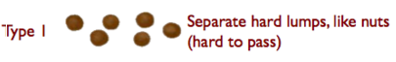 |  |  |  |  |  | 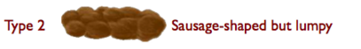
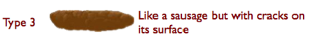 |  |  |  |  |  | 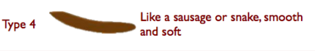
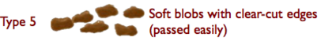 |  |  |  |  |  | 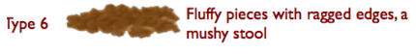
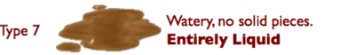 |  |  |  |  |  | Reproduced by kind permission of  Dr KW Heaton, Reader in Medicine at the University of Bristol
Date | Time | Colour | Type No | Blood | Mucus | Amount | Comments |  |  | Initials

